General Factors in Composting

- Prewet: Paddy straw does not possess more wax coating like wheat/mustard straw, it absorbs water as soon as it comes in contact with water. Therefore, the period of prewet is calculated by number of hours rather than number of days. Paddy straw heats more quickly than wheat straw during all stages of composting. This is believed to be due to differences in wax and silica content of the plant cuticle, as well as both microbial diversity and abundance on rice straw. The result is more rapid degradation and lower C/N ratio in paddy straw compost.

- Level of fermentation: Since the leaf to stem ratio is high in paddy straw, leafy material ferments faster than stem. This over fermented material makes the compost soggy and soft. This makes water management in the compost difficult and thus average yield is less than 20%!

- Structure of straw: The outer layer is made of cellulose and hemicellulose, main source of Carbon. as the straw grow and turn from green to pale brown color. This process can be compared to the building of a wall, where cellulose is the brick, hemicellulose is the cement sand mixture and lignin is reinforcement bar, making the straw hard. Leaves being soft have less of lignin. During the prewet and Phase 1, cellulose is decomposed and act as sponge and retain the water. Lignin is not touched and remain as such and is an excellent food for mushroom mycelium.

- Adding Inorganic nitrogen like urea should be minimized as it would make the end products softer. It needs some experience as making paddy straw compost is relatively difficult compared to wheat/mustard straw compost. It may be filled in beds loose and is more suited to bed growing than bag growing.

- Some farmers make compost by mixing wheat/mustard straw and paddy straw. Since the level of fermentation is different for the two materials, creating a uniform compost may not be possible. By the time wheat/mustard straw have softened enough, the paddy straw is over fermented making it sticky and soggy. Adding 10% of lengthy straw to short structure straw is a different game as we add it to give volume to the compost for better aeration, and not for the nutrition.

- A good composting person would understand the nature, age and quality of straw made available, adapt the water management, time duration of prewet and Phase 1, level of fermentation and formulations to make a productive compost

Checklist for selection of Raw Material (RM)

- All RM should be free from roots, soil, stones, ropes and other polythene/plastic materials.
- Always store RM on concrete surface.
- Fresh RM particles should not be contaminated with phase 2 compost.
- Rice straw contains 30 to 35% cellulose, 25 to 30% hemicellulose, 15 to 28% lignin, and 4 to 7% ashes.
- Whereas bagasse contains higher lignin and lower amount of carbohydrates (cellulose & hemi cellulose), 32 to 43% cellulose, 19 to 24% hemicellulose, 25 to 32% lignin, and 2 to 6% ash.
Notes Mixing & Flipping:

- It is the first process of mixing raw materials i.e., straw and manure, more uniformly with the help of
Front-end Loader.
- Mixing, mixing, mixing and again mixing is the secret of mushroom composting to get more homogeneous food material and then piled to allow composting organisms to start working.
- Flipping operation should begin early in the morning under the supervision of compost manager to judge the uniformity of raw materials mixing.
- During pre-wet it is advisable to flip or turn the compost every day. After windrow is built, compost should turn every alternate day unless compost temperatures have not peaked

Notes on Turner Mixing (Windrow):

- The process is carried out on a concrete platform with a slight slope to collect leachate into soaking pit. After windrow formation(T0) it should be turned 2 more times (T1 &T2) to regulate raw material placement by mixing, aeration, watering and heat distribution. add as much water as possible without runoff at T0 & T1 turns.
- The high pile temperatures draw ambient air through the sides of the stack, and as the air is heated, it rises upward through the stack—a process commonly referred to as the chimney effect.
- The sides of the pile should be firm and dense, yet the center must remain loose throughout Phase I composting.
- Straw softens during turnings and the materials become less rigid and more compact while substrate density increases.
- The number of turnings and the time between turnings depends on the condition of starting raw material and time necessary for compost to heat.
- Add water as much as possible without runoff during pre-wet conditioning and T0 and T1
- Avoid adding too much water in early during phase1- Moister should not exceed 79% water should drip from compost squeezed in the hand.

Note on Bunker Loading:

- In the first 12hrs water seeps out of the material during periods when the fan is switched off
- Periodically open the end cap of spigot pipes at blower side to remove the excess water/ clogging.
- Don’t waste this water as it is full of nutrient, collect this water into the soaking pit for further use.
.
- Check the temperature at regular intervals, Minimum temperature should be 63°C and Maximum should be 78°C. If temperature is below 63°C then the growth of microorganisms will slow down. In this situation, check air, increase the flow rate of blower, so that air provides oxygen for the growth of thermophilic organisms that lead to increase in the temperature
- Also check the moisture content if excess moisture is there it will lead to reduction of growth of micro-organisms by filling the interspaces of compost in such case there is reduction in temperature which can be increased by increasing the air flow rate of blower.
- If moisture is less, it leads to reduction in the growth of micro­organisms in such case add water during reloading time
- JCB, Conveyers & Hopper should be cleaned with forced water before and after filling.
- Nitrogen content determines the temperature of the compost. Starting N content of compost should be 1.75% before composting.

Phase - II
Objectives

- The first objective of Phase II is to pasteurize the composted substrate. The composted substrate is pasteurized to reduce or eliminate the bad microbes such as insects, other fungi, and bacteria. This is not a complete sterilization but a selective killing of pests that will compete for food or directly attack the mushroom. At the same time, this process minimizes the loss of good microbes.
- The second goal of Phase II is to complete the composting process. Completing the composting process means eliminating all remaining simple soluble sugars and gaseous and soluble ammonia created during Phase I composting. Since ammonia is toxic to the mushroom mycelium, it must be converted to food the mushroom can use.
- The good microbes in Phase II convert toxic ammonia in solution and amine (other readily available nitrogen compounds) substances into protein—specific food for the mushroom.
- At the end of Phase II, volatile ammonia (concentration more than 0.05 percent) will inhibit mushroom spawn growth. Generally, ammonia concentrations above 0.10 percent can be easily detected by a person and are toxic to the spawn.
- Most of this conversion of ammonia and carbohydrates is accomplished by the growth of the microbes in the compost.
- The composted substrate throughout Phase II should appear to have moderate “fire fang”—a term referring to the white-flecking microbial growth pattern of the thermophilic microorganism
- Pasteurization (peak heat, boost) should be completed toward the start of Phase II.
- the more ammonia-utilizing microbes grow best in the temperature range of 47–49ºC. The longer the microbes in the composted substrate remain in this optimum range with all the critical growth requirements available, the faster the ammonia will be converted.
- A good rule of thumb is not to drop the composted substrate temperature more than 5ºC per 24 hours, which maintains the compost substrate in the desired range for about 4 or more days.
- During the composting process the ph. value must decrease by at least half a ph. point during phase2 and 1Ph point from phase 2 to 3
- Phase one composting consists of biomass, made up of actinomycetes, bacteria, fungi and yeast. The buildup of these organisms is correlated with the rise in temperature during composting. Through their metabolism, they convert dry matter to sugars, proteins, CO2, ammonia and water (Laborde et al.1986).
- Moisture content at tunnel filling should be 73 to 75 percent.

Summarized Monitoring Steps in Phase I

Parameter | Likely Out Come at the end of phase I if No action is taken | Suggested action to optimize key parameters | Likely outcome as a result of the action at end of phase I
Core Temperature (In degree)
75 to 80 | Less thermophilic Bacteria & Less Raw Material breakdown | Reloading of Raw Material by adding more water | More uniform breakdown of Raw Material
55 to 65 | Optimum condition | No intervention | Uniform Raw Material breakdown
40 to 50 | Poor microbial activity,  Low pH & N content | Add N rich raw material, add moister, increase aeration rate. | Increase of microbial activity leads to increase in Temperature.
Moister Content
79% | Anaerobic and poor Composting | Immediate Reloading of Bunker
75% - 77% | Intervention not required
70% | Over drive | Reloading with water
N content
1.4% to 1.6% | Optimum Nitrogen content. Intervention not required | - | Substrate nitrogen should be +/- 2%
pH
9.0 | High pH | One more extra turning | Optimum Ph – 7.8 to 8.2
8.0 | Intervention not required
7.5 | Low pH | Addition of Nitrogen rich Raw Material | Optimum Ph – 7.8 to 8.2
Moister Content
79% | Anaerobic and poor Composting | Immediate Reloading of Bunker

Characteristics of the compost after phase1
Sr. No. | Checklist | Remark/ Observation
1 | Substrate density, colour & stickiness
2 | Straw density long or broken
3 | Moisture %
4 | Smell of ammonia (Mild / Extreme )
5 | Ammonia content (Normal 800-1000 ppm)
6 | PH (Normal range 8.2 - 8.5)
7 | Nitrogen content

Note

- At the end of Phase I, the substrate should be dense, chocolate brown in colour and sticky and hands get dirty and wet when squeezed.
- Straw rather long but can be broken with some force.
- Moisture should be73-75%
- Mild smell of ammonia. pH value should be around 8.2 - 8.5 and Nitrogen content between 1.5-2.0% and ammonia around 800-1000 ppm.
- The substrate still has some structure so aeration can be maintained during Phase II composting.

- Levelling, Conditioning 1 and Heating up

Sr. No. | Checklist | Remark/ Observation
1 | All the four sensors have to be placed into the compost at same level.
2 | Make sure the compost difference of all the four sensors to be low.
3 | Note the Temperature at regular intervals on hourly basis and inform the manager if there is any fluctuation in the desired temperature.
4
5
6
7

Note:
- The compost is filled in the bulk chamber up to the height of 1.8- 2.0 meters in such a way that one square meter of space occupies approximately 800- 1000 kg of compost.
- Immediately after filling, all the doors are closed and the blower is switched on to bring the compost, plenum (air below and compost) air above the compost at a uniform temperature (around 45-48°C).
- Levelling may take 6-10 hours and at this stage 10-50% fresh air is introduced in the tunnel.
- Pre-pasteurization conditioning (PPC) Temperature is maintained at 45- 49°C
- During this phase major part of NH3 gets fixed in lignin-humus complex and excess of ammonia is released into the atmosphere
- Compost should not be conditioned below 47.5°C
- Enough of oxygen is supplied (02 concentration above 10%) to the compost mass to maintain fully aerobic conditions.

- Pasteurization

Sr. No. | Checklist | Remark/ Observation
1
2
3
4
5
6
7

Note:

- Main purpose of pasteurization is to kill or inactivate harmful organisms.

- After Pre-Pasteurization conditioning, opening of the damper is narrowed down which will gradually increase the temperature of the compost by approximately 1°C/hr
- compost is pasteurized properly if it is kept at 59.5°C for 8-10 hours. If compost is active, its temperature starts rising immediately after filling and may rise by 1 °C per hour and the required temperature of pasteurization can be achieved in few hours only by self-generation of heat.
- In no case difference in the temperature above the compost (air temperature) and inside the compost should be less than 1°C if it is more than that (> 1°C, maximum) than it is all the better.
- Duration of the pasteurization is normally 8-10 hours. It may increase if
- there is any kind of infestation in previous batch

- Post Pasteurization Conditioning (POPC)

Sr. No. | Checklist | Remark/ Observation
1 | Ensure the spawning Hall Door are always in closed condition while unloading.
2 | Contamination of cooldown compost by dust and debris must be avoided.
3 | Before opening the tunnel doors for unloading, Sterilize the tunnel winch, wagon, conveyor and surrounding floor areas with formalin solution.

Note:
- Post pasteurization conditioning of the compost, which is normally accomplished in 3-4 days
- After pasteurization, fresh air is again introduced in the tunnel and temperature of the compost is brought down @ l.5°C/hour and finally maintained between 45-48°C till there is no detectable smell of ammonia (less than 10 ppm) in the compost.
- Temperature of the compost is gradually brought down to 25-30°C after conditioning by introduction of fresh air in the tunnel and when this temperature reaches, the compost is ready for spawning.

Changes during composting of Phase I and Phase II

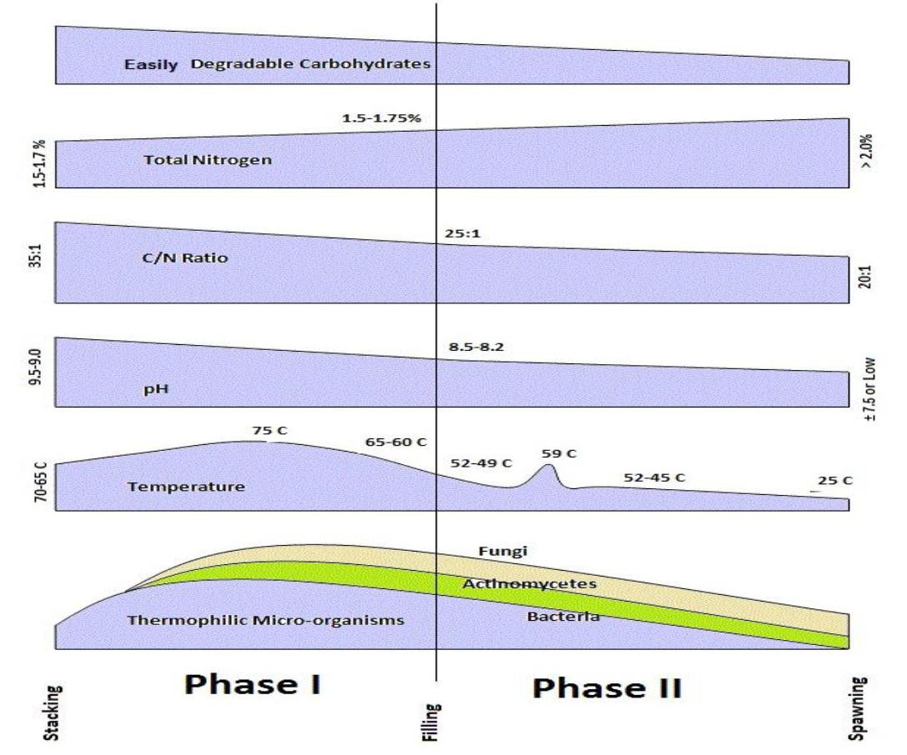

Summarized Monitoring Steps in Phase II

 | Parameter | Likely Out Come at the end of phase II if No action is taken | Suggested action to optimize key parameters | Likely outcome as a result of the action at end of phase II
Airflow – Leveling (Temperature)
0 -14 hrs.  (Day 1) | Tunnel Top Temp
0 -14 hrs.  (Day 1) | Less than 45 | Lower in N content and over degradation in bunker | Decrease the Fan speed | Ideal Compost
0 -14 hrs.  (Day 1) | 45 - 48 | No Intervention required
0 -14 hrs.  (Day 1) | More than 50 | High in N content and under degradation | Increase the Fan speed | Ideal Compost
0 -14 hrs.  (Day 1) | Compost Temp
0 -14 hrs.  (Day 1) | Less than 47 | Lower in N content and over degradation in bunker | Decrease the Fan speed | Ideal Compost
0 -14 hrs.  (Day 1) | 47 – 50 | No Intervention required
0 -14 hrs.  (Day 1) | More than 51 | High in N content and under degradation | Increase the Fan speed | Ideal Compost
0 -14 hrs.  (Day 1) | Plenum Temp
0 -14 hrs.  (Day 1) | Less than 45 | Lower in N content and over degradation in bunker | Decrease the Fan speed | Ideal Compost
0 -14 hrs.  (Day 1) | 45 – 48 | No Intervention required
0 -14 hrs.  (Day 1) | More than 51 | High in N content and under degradation | Increase the Fan speed | Ideal Compost
Heating up for Pasteurization (Temperature)
15 – 28 hrs.  (Day 1)  (Increase in the temperature per hour will be .70 – 1.2) | Tunnel Top Temp
 | Compost Temp (58 – 60)
 | Less than 10 hrs. | Lower in N content and over degradation in bunker | Decrease the Fan speed | Ideal Compost
 | 10 – 12 hrs. | No Intervention required
 | More than 14 hrs. | High in N content and under degradation | Increase the Fan speed | Ideal Compost
 | Plenum Temp
 | Not Less than 55 | No Intervention required
 | More than 55 | High in N content and under degradation | Increase the fan speed along with the fresh air
Temperature at Pasteurization (During this stage, Fan speed should not be less than 75%)
29 – 40 hrs.  (Day 2) | Tunnel Top Temp
29 – 40 hrs.  (Day 2) | More than 63 | Less of the microbes which will result in poor yield | Need to reduce the temperature by increasing airflow in the tunnel (Internally / Fresh Air) | Proper pasteurization
29 – 40 hrs.  (Day 2) | 56 - 58 | No Intervention required
29 – 40 hrs.  (Day 2) | Less than 55 | Improper pasteurization | - Check for the fan speed  - Check for the air damper  - Check for duration of phase I  - Check compost formulation | Damage reduction to achieve proper pasteurization
29 – 40 hrs.  (Day 2) | Compost Temp
29 – 40 hrs.  (Day 2) | More than 63 | Less of the microbes which will result in poor yield | Need to reduce the temperature by increasing airflow in the tunnel | Proper pasteurization
29 – 40 hrs.  (Day 2) | 58 - 60 | No Intervention required
29 – 40 hrs.  (Day 2) | Less than 54 | Improper pasteurization | - Check for the fan speed  - Check for the air damper  - Check for duration of phase I  - Check compost formulation | Damage reduction to achieve proper pasteurization
29 – 40 hrs.  (Day 2) | Plenum Temp
29 – 40 hrs.  (Day 2) | More than 60 | Less of the microbes which will result in poor yield | Need to reduce the temperature by increasing airflow in the tunnel | Proper pasteurization
29 – 40 hrs.  (Day 2) | 56 - 58 | No Intervention required
29 – 40 hrs.  (Day 2) | Less than 55 | Improper pasteurization | - Check for the fan speed  - Check for the air damper  - Check for duration of phase I  - Check compost formulation | Damage reduction to achieve proper pasteurization
Cooling Down for Conditioning (To bring down the temperature from 58 to 51 within 14 hours)
41 – 54 hrs.  (Day 3) | Tunnel Top Temp
41 – 54 hrs.  (Day 3) | More than 51 | Less microbe’s multiplication | Increase the airflow (Internal / fresh air) | Uniform compost temperature
41 – 54 hrs.  (Day 3) | 51 | No intervention is required
41 – 54 hrs.  (Day 3) | Less than 51
41 – 54 hrs.  (Day 3) | Compost Temp
41 – 54 hrs.  (Day 3) | More than 51 | Less microbe’s multiplication | Increase the airflow (Internal / fresh air) | Uniform compost temperature
41 – 54 hrs.  (Day 3) | 51 | No intervention is required
41 – 54 hrs.  (Day 3) | Less than 51
41 – 54 hrs.  (Day 3) | Plenum Temp
41 – 54 hrs.  (Day 3) | More than 49 | Less microbe’s multiplication | Increase the airflow (Internal / fresh air) | Uniform compost temperature
41 – 54 hrs.  (Day 3) | 49 | No intervention is required
41 – 54 hrs.  (Day 3) | Less than 49
Conditioning (To bring down the temperature from 51 to 45 within 48 hours)
55 – 102 hrs.  (Day 4) | Tunnel Top Temp
55 – 102 hrs.  (Day 4) | More than 49 | Less microbe’s multiplication | Increase the airflow (Internal / fresh air) | Uniform compost temperature
55 – 102 hrs.  (Day 4) | 49 - 45 | No intervention is required
55 – 102 hrs.  (Day 4) | Less than 45 | Less microbe’s multiplication | Reduce the airflow | Uniform compost temperature
55 – 102 hrs.  (Day 4) | Compost Temp
55 – 102 hrs.  (Day 4) | More than 48 | Less microbe’s multiplication | Increase the airflow (Internal / fresh air) | Uniform compost temperature
55 – 102 hrs.  (Day 4) | 48 - 44 | No intervention is required
55 – 102 hrs.  (Day 4) | Less than 44 | Less microbe’s multiplication | Reduce the airflow | Uniform compost temperature
55 – 102 hrs.  (Day 4) | Plenum Temp (It should not be less than 42 during Conditioning stage)
55 – 102 hrs.  (Day 4) | More than 48 | Less microbe’s multiplication | Increase the airflow (Internal / fresh air) | Uniform compost temperature
55 – 102 hrs.  (Day 4) | 47 - 43 | No intervention is required
55 – 102 hrs.  (Day 4) | Less than 42 | Less microbe’s multiplication | Reduce the airflow | Uniform compost temperature
Conditioning (Maintain the temp of 45 for next 40 hours)
103 – 142 hrs.  (Day 5 & 6) | Tunnel Top Temp
103 – 142 hrs.  (Day 5 & 6) | More than 47 | Less microbe’s multiplication | Increase the airflow (Internal / fresh air) | Uniform compost temperature
103 – 142 hrs.  (Day 5 & 6) | 45 | No intervention is required
103 – 142 hrs.  (Day 5 & 6) | Less than 42 | Less microbe’s multiplication | Reduce the airflow | Uniform compost temperature
103 – 142 hrs.  (Day 5 & 6) | Compost Temp
103 – 142 hrs.  (Day 5 & 6) | More than 48 | Less microbe’s multiplication | Increase the airflow (Internal / fresh air) | Uniform compost temperature
103 – 142 hrs.  (Day 5 & 6) | 45 | No intervention is required
103 – 142 hrs.  (Day 5 & 6) | Less than 43 | Less microbe’s multiplication | Reduce the airflow | Uniform compost temperature
103 – 142 hrs.  (Day 5 & 6) | Plenum Temp (It should not be less than 42 during this stage)
103 – 142 hrs.  (Day 5 & 6) | Less than 43 | Less microbe’s multiplication | Reduce the airflow | Uniform compost temperature
103 – 142 hrs.  (Day 5 & 6) | 45 | No intervention is required
103 – 142 hrs.  (Day 5 & 6) | Less than 42 | Less microbe’s multiplication | Reduce the airflow | Uniform compost temperature
Cooling Down II (Bring down the temperature to 24 next 8 hours)
143 - 150 hrs.  (Day 7) | Tunnel Top Temp
143 - 150 hrs.  (Day 7) |  | No intervention is required
143 - 150 hrs.  (Day 7) | Compost Temp
143 - 150 hrs.  (Day 7) | Not more than 28 | Compost not ready for transfer to Growing Room | Increase the airflow till the optimum temp is achieved | Ideal compost for shifting
143 - 150 hrs.  (Day 7) | 24 - 26 | No intervention is required
143 - 150 hrs.  (Day 7) | Less than 22
143 - 150 hrs.  (Day 7) | Plenum Temp
143 - 150 hrs.  (Day 7) |  | No intervention is required

Tunnel  Readings | System Observation | Remark/ Observation
Day 1
Day 2
Day 3
Day 4
Day 5
Day 6
Day 7

